**E-Road Management System**

P.Premje, V.Thivaharan, Y.Tharangini, R.Darshitha, **Supervisor:** Dr. Samantha Thelijjagoda,   
**Co-Supervisor:** Mr.Buddika Kasthuriyarachchy.

**Sri Lanka Institute of Information Technology**

**Abstract**

*Monitoring of road traffic in Sri Lanka has become a major task for police. Due to increase in volume of road traffic in the Island the Sri Lanka police facing many challenges to get control of it. But this is a difficult task to manually control the traffic. The author intends to provide a traffic monitoring system, which can be a solution for above mentioned problems. Therefore the major purpose of the system is to provide safe road accessibility facilities to the people through road development maintenance and providing legal provisions through an optimum road network constructed by efficient utilization of resources.*

**Keywords**

ERMS – E-Road Management System

ESA – E-Statistical Analyzer

EPI – E-Path Identifier

EDMS-E-Destination Management Services

EMT-E-Mobile Tracker

**1. Introduction**

E-Road Management System is a web system, which is completely implemented using ASP.NET and MSSQL to provide most viable option for solving and managing traffic in Sri Lanka. Automotive technologies are gaining ground in modern road traffic-control systems, since the number of road vehicles and passengers is rapidly growing.

There is a perpetual need for safety-critical traffic automation, and traffic engineering makes the dynamic or static analysis and the synthesis of automotive vehicle technologies possible. The main goal of engineering is the planning and management of traffic systems.

The project supports the development of reliable and optimal control structures for urban traffic and for motorway systems.

The intelligent and cooperative set-up of actuation and its linkage to the central control system is vital for avoiding traffic jams and accidents.

However, when it comes to managing traffic there are several major disadvantages in using computer software.

1. **Lack of software availability**

There are number of software solutions that can manage road traffic throughout the World but it’s high in cost to inherit them to Sri Lanka.

1. **High Cost**

Most of the software related to road traffic management cannot afford, because of their high hardware requirements. Developing countries like Sri Lanka need a solution to overcome road traffic along with the development of the Country.

1. **Lack of Knowledge and Time**

Almost all of the available software solutions that are focused on SOHO environments require a considerable learning curve to use them effectively, but many of the SOHO owners dose not posses neither knowledge nor the time to gain knowledge to spend on these software.

E-Road Management System (ERMS) is created to overcome many of the above mentioned disadvantages. ERMS is a fully computerize software, highly user friendly with minimal human interference.

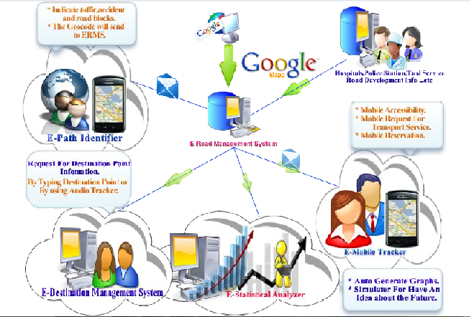

**2. Methodology**

There is a need of well-designed solution that would allow people to use a single standardized E-Road Management System that would be accepted by all major responding agencies, volunteers, and governments.

**2.1 Project Approach**

The waterfall approach is a popular version of the system development life cycle model in software engineering. Waterfall model is often considered as classic approach to the system development which describes a development method that is linear and sequential.

**2.2 Agile methods and Non Agile methods**

Agile is an iterative and incremental approach to software development which is performed in a highly collaborative manner by self organizing teams. [2]

**2.3 Research Methodology Study**

A methodology is a system of organizing principles underlying an area of study. It is a form of standardization or framework that allows continuous review, refine and validate the findings, until knowledge that is as accurate.

**2.4 Rapid Application Development**

Rapid Application Development (RAD) is a development lifecycle designed to give much faster development and higher quality results. Rapid Application Development is far more than a simple management strategy.

2.5 Dynamic Systems Development Method (DSDM)

Prototyping is one of the characteristics of DSDM which is used to have a clear picture of all aspects of the system.

Since the users are actively involved in the development of the system, meeting stakeholder requirements and expectations are possible by adapting to DSDM methodology. System is delivered on time and on budget within DSDM. [3]

**2.5 Summery**

Iterative or incremental methodologies provide a cyclic approach to software development, which is especially useful for this particular project where requirements change often and response need to be quick. There are several iterative methodologies have been discussed above, including RAD, DSDM, and USDP. DSDM has been chosen to carry out this project as it allow designing from the early stage of requirement gathering. Changes can be incorporated into the system according to the requirement gathering process. DSDM also allow prototyping which helps to ensure that the system is designed correctly and the stakeholder expectations are met. In addition, using DSDM helps to deliver the product within the time frame.

**3.** **Conclusion and Future Work**

The ERMS team was successfully implemented the system to fulfill the requirements as stated above.  
In the future it is planned to improve the system in following ways.

ESA –

Applying efficient algorithms using neural network to analysis large set of historical data. So it helps to make the predictions more accurate and efficient using the simulators.

EMT –

Providing real-time street view images during the route tracking process, so it helps the Client who is requesting to reach destination sooner.

EPI –

Without human interference, in future can use **traffic cameras** to monitor the traffic situations in each and every place.

It is a valuable source of traffic condition information that is provided to the media and the public [1].

With the help of image processing technology can automate the calculate traffic volume.

**5. References**

[1] R. Johnson*, Department of Transportation, New York State Department of Transportation:* 2011,

[2] J Ronkainen, *Agile Software Development Method* : *the Role of Social Protection*, 2002 - Citeseer

[3]J Stapleton*, DSDM, dynamic systems development method:* method in practice,1997

# [4] [James Martin](http://www.google.com/search?tbo=p&tbm=bks&q=inauthor:%22James+Martin%22), *Rapid application development*, Department of Transportation: 1991,